**NAME:………………………………………………………………STREAM………………….**

**545/1**

**NLSC CHEMISTRY**

**P1 2024**

**AOI 1 (1HR)**

* Responses are to be written in the answer booklet provided.
* All working must be clearly shown.

|  |  |  |  |  |
| --- | --- | --- | --- | --- |
| **For assessment use only** | | | | |
| Item 1 | **A** | **B** | **C** | **D** |
|  |  |  |  |

**ITEM ONE**

In one of the towns in Uganda, residents are facing an unexpected challenge of water wasting soap. The locals are frustrated, do not understand the cause and what to do. However, they have heard of other detergents on market that work better but they need more advice on this.

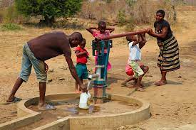 

A resident has sought your assistance, confident that you can use your knowledge of chemistry to provide help

**TASK**

Write down the advice you would give the resident.